Eligibility Criteria for Free and Reduced Price Meals
Effective July 1, 2016

Household | Maximum Household Income |  |  | Maximum Household Income
Size | Eligible for Free Meals |  |  | Eligible for Reduced Price Meals
 | Annually | Monthly | Weekly | Annually | Monthly | Weekly
1 | $15,444 | $1,287 | $297 | $21,978 | $1,832 | $423
2 | 20,826 | 1,736 | 401 | 29,637 | 2,470 | 570
3 | 26,208 | 2,184 | 504 | 37,296 | 3,108 | 718
4 | 31,590 | 2,633 | 608 | 44,955 | 3,747 | 865
5 | 36,972 | 3,081 | 711 | 52,614 | 4,385 | 1,012
6 | 42,354 | 3,530 | 815 | 60,273 | 5,023 | 1,160
7 | 47,749 | 3,980 | 919 | 67,951 | 5,663 | 1,307
8 | 53,157 | 4,430 | 1,023 | 75,647 | 6,304 | 1,455
Each add’l
member | + 5,408 | + 451 | + 104 | + 7,696 | + 642 | + 148

Family/Household means a group of people who may or may not be related and who do not live in an institution or a boarding house, but who are living as one economic group. Students who are temporarily away at school should be counted as members of the family; however, students who are full-time residents of an institution are considered a family of one.

Gross Income means income before deductions for income taxes, employee's social security taxes, insurance premiums, charitable contributions, bonds, etc. It includes the following:

- Monetary compensation for services, including wages, salary, commissions, or fees;
- Net income from non-farm self-employment;
- Net income from farm self-employment;
- Social security;
- Dividends or interest on savings or bonds or income from estates or trusts;
- Net rental income;
- Public assistance or welfare payments;
- Unemployment compensation;
- Government civilian employee or military retirement, or pensions, or veterans payments;
- Private pensions or annuities;
- Alimony or child support payments;
- Regular contributions from persons not living in the household;
- Net royalties; and
- Other cash income. Other cash income would include cash amounts received or withdrawn from any source including savings, investments, trust accounts, and other resources which would be available to pay the price of a child's meal.

Income does not include any income or benefits received under any Federal program, which are excluded from consideration as income by any legislative prohibition.

In a household where there is income from wages and self-employment and the self-employment reflects a negative net income, consider that income as zero so as not to offset the wages earned.

In applying guidelines, the family's current rate of income should be used in determining eligibility.

Current Income is defined as income received during the month prior to application if such income is representative. Where the prior month's income was much higher or lower than usual, expected income for this year (12 months starting from the prior month) may be used; for example, self-employed people, farmers, and migrant workers.

Foster Children whose care and placement is the responsibility of the State or who is placed by a court with a caretaker household is categorically eligible for free meals and may be certified without a application. Households with foster and non foster children may chose to include the foster child as a household member, as well as any personal income earned by the foster child on the same household application that includes the non foster children. Foster children on the DC list are free eligible. Foster children cannot extend eligibility to household members.

Institutionalized Children are considered a one-member family and only monies the child actually receives and controls shall be considered as income for determining eligibility.

Adopted Children for whom a household has accepted legal responsibility is considered to be a member of that household. If the adoption is a “subsidized” adoption, which may include children with special needs, the subsidy is included in the total household income.

Because some adopted children were first placed in families as foster children, parents may not be aware that, once the child is adopted, he/she must be determined eligible based on the economic unit and all income available to that household, including any adoption assistance, is counted when making eligibility determination.

Letter to Parents
FREQUENTLY ASKED QUESTIONS ABOUT FREE AND REDUCED PRICE SCHOOL MEALS

Dear Parent/Guardian:

Children need healthy meals to learn. South Nodaway School District offers healthy meals every school day. Breakfast costs 80¢; lunch costs $2.15 for K-6 and $2.40 for JH/HS. Your children may qualify for free meals or for reduced price meals. Reduced price is 30¢ for breakfast and 40¢ for lunch. This packet includes an application for free or reduced price meal benefits, and a set of detailed instructions. Below are some common questions and answers to help you with the application process.

1. Who can get free OR REDUCED PRICE meals?
  - All children in households receiving benefits from the Food Stamp Program/Supplemental Nutrition Assistance Program (SNAP), the Food Distribution Program on Indian Reservations (FDPIR) or Temporary Assistance/Temporary Assistance for Needy Families (TANF), are eligible for free meals.
  - Foster children that are under the legal responsibility of a foster care agency or court are eligible for free meals.
  - Children participating in their school’s Head Start program are eligible for free meals.
  - Children who meet the definition of homeless, runaway, or migrant are eligible for free meals.
  - Children may receive free or reduced price meals if your household’s income is within the limits on the Federal Income Eligibility Guidelines. Your children may qualify for free or reduced price meals if your household income falls at or below the limits on this chart.
Household Size | Annually | Monthly | Weekly
1 | $21,978 | $1,832 | $423
2 | 29,637 | 2,470 | 570
3 | 37,296 | 3,108 | 718
4 | 44,955 | 3,747 | 865
5 | 52,614 | 4,385 | 1,012
6 | 60,273 | 5,023 | 1,160
7 | 67,951 | 5,663 | 1,307
8 | 75,647 | 6,304 | 1,455
For each add’l person add | + 7,696 | + 642 | + 148

2. HOW DO I KNOW IF MY CHILDREN QUALIFY AS homeless, MIGRANT, OR RUNAWAY? Do the members of your household lack a permanent address? Are you staying together in a shelter, hotel, or other temporary housing arrangement? Does your family relocate on a seasonal basis? Are any children living with you who have chosen to leave their prior family or household? If you believe children in your household meet these descriptions and haven’t been told your children will get free meals, please call or e-mail Johnnie Silkett 652-3221 or johnnie.silkett@southnodaway.k12.mo.us.
3. Do I need to fill out an application for each child? No. Use one Free and Reduced Price School Meals Application for all students in your household. We cannot approve an application that is not complete, so be sure to fill out all required information. Return the completed application to: Sonya Buckles or Marcia Schieber, 209 Morehouse, Barnard, Mo. 64423 or call 652-3727 or 652-3718.

4. SHOULD I FILL OUT AN APPLICATION IF I RECEIVED A LETTER THIS SCHOOL YEAR SAYING MY CHILDREN ARE ALREADY APPROVED FOR FREE MEALS? No, but please read the letter you got carefully and follow the instructions. If any children in your household were missing from your eligibility notification, contact Johnnie Silkett, 209 Morehouse, Barnard, Mo. 64423, johnnie.silkett@southnodaway.k12.mo.us immediately.
5. MY CHILD’S APPLICATION WAS APPROVED LAST YEAR. DO I NEED TO FILL OUT A NEW ONE? Yes. Your child’s application is only good for that school year and for the first few days of this school year. You must send in a new application unless the school told you that your child is eligible for the new school year.
6. I GET WIC. CAN MY CHILDREN GET FREE MEALS? Children in households participating in WIC may be eligible for free or reduced price meals. Please send in an application.
7. Will the information I give be checked? Yes. We may also ask you to send written proof of the household income you report.
8. If I don’t qualify now, may I apply later? Yes, you may apply at any time during the school year. For example, children with a parent or guardian who becomes unemployed may become eligible for free and reduced price meals if the household income drops below the income limit.
9. What if I disagree with the school’s decision about my application? You should talk to school officials. You also may ask for a hearing by calling or writing to: Johnnie Silkett, 209 Morehouse, Barnard, Mo. 64423, johnnie.silkett@southnodaway.k12.mo.us.
10. May I apply if someone in my household is not a U.S. citizen? Yes. You, your children, or other household members do not have to be U.S. citizens to apply for free or reduced price meals.
11. What if my income is not always the same? List the amount that you normally receive. For example, if you normally make $1000 each month, but you missed some work last month and only made $900, put down that you made $1000 per month. If you normally get overtime, include it, but do not include it if you only work overtime sometimes. If you have lost a job or had your hours or wages reduced, use your current income.
12. WHAT IF SOME HOUSEHOLD MEMBERS HAVE NO INCOME TO REPORT? Household members may not receive some types of income we ask you to report on the application, or may not receive income at all. Whenever this happens, please write a 0 in the field. However, if any income fields are left empty or blank, those will also be counted as zeroes. Please be careful when leaving income fields blank, as we will assume you meant to do so.
13. We are in the military. do we REPORT OUR INCOME DIFFERENTLY? Your basic pay and cash bonuses must be reported as income. If you get any cash value allowances for off-base housing, food, or clothing, or receive Family Subsistence Supplemental Allowance payments, it must also be included as income. However, if your housing is part of the Military Housing Privatization Initiative, do not include your housing allowance as income. Any additional combat pay resulting from deployment is also excluded from income.
14. WHAT IF THERE ISN’T ENOUGH SPACE ON THE APPLICATION FOR MY FAMILY? List any additional household members on a separate piece of paper, and attach it to your application. Contact Sonya Buckles or Marcia Schieber, 209 Morehouse, Barnard, Mo. 64423 or call 652-3727 or 652-3718 to receive a second application.
15. My family needs more help. Are there other programs we might apply for? To find out how to apply for the Food Stamp Program/SNAP or other assistance benefits, contact your local assistance office or call 1-855-373-4636.

If you have other questions or need help, call 660-652-3221.

Sincerely,
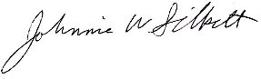
Johnnie Silkett

USDA Non-discrimination Statement:

In accordance with Federal civil rights law and U.S. Department of Agriculture (USDA) civil rights regulations and policies, the USDA, its Agencies, offices, and employees, and institutions participating in or administering USDA programs are prohibited from discriminating based on race, color, national origin, sex, disability, age, or reprisal or retaliation for prior civil rights activity in any program or activity conducted or funded by USDA.

Persons with disabilities who require alternative means of communication for program information (e.g. Braille, large print, audiotape, American Sign Language, etc.), should contact the Agency (State or local) where they applied for benefits. Individuals who are deaf, hard of hearing or have speech disabilities may contact USDA through the Federal Relay Service at (800) 877-8339. Additionally, program information may be made available in languages other than English.

To file a program complaint of discrimination, complete the USDA Program Discrimination Complaint Form, (AD-3027) found online at: http://www.ascr.usda.gov/complaint_filing_cust.html, and at any USDA office, or write a letter addressed to USDA and provide in the letter all of the information requested in the form. To request a copy of the complaint form, call (866) 632-9992. Submit your completed form or letter to USDA by:

(1) mail: U.S. Department of Agriculture
Office of the Assistant Secretary for Civil Rights
1400 Independence Avenue, SW
Washington, D.C. 20250-9410;

(2) fax: (202) 690-7442; or

(3) email: program.intake@usda.gov.

This institution is an equal opportunity provider.

HOW TO APPLY FOR FREE AND REDUCED PRICE SCHOOL MEALS
Please use these instructions to help you fill out the application for free or reduced price school meals. You only need to submit one application per household, even if your children attend more than one school in South Nodaway School District. The application must be filled out completely to certify your children for free or reduced price school meals. Please follow these instructions in order! Each step of the instructions is the same as the steps on your application. If at any time you are not sure what to do next, please contact Sonya Buckles or Marcia Schieber, 209 Morehouse, Barnard, Mo. 64423 or call 652-3727 or 652-3221.
STEP 1: LIST ALL HOUSEHOLD MEMBERS WHO ARE INFANTS, CHILDREN, AND STUDENTS UP TO AND INCLUDING GRADE 12
Tell us how many infants, children, and school students live in your household. They do NOT have to be related to you to be a part of your household.
Who should I list here? When filling out this section, please include ALL members in your household who are:
- Children age 18 or under AND are supported with the household’s income;
- In your care under a foster arrangement, or qualify as homeless, migrant, or runaway youth;
- Students attending South Nodaway/Grade level, regardless of age.
List each child’s name. Print each child’s name. Use one line of the application for each child. When printing names, write one letter in each box. Stop if you run out of space. If there are more children present than lines on the application, attach a second piece of paper with all required information for the additional children. | Building name/Grade. If child is a student, list building name and grade. | Do you have any foster children? If any children listed are foster children, mark the “Foster Child” box next to the child’s name. If you are ONLY applying for foster children, after finishing STEP 1, go to STEP 4.  Foster children who live with you may count as members of your household and should be listed on your application. If you are applying for both foster and non-foster children, go to step 3. | Are any children homeless, migrant, or runaway? If you believe any child listed in this section meets this description, mark the “Homeless, Migrant, Runaway” box next to the child’s name and complete all steps of the application.
PLEASE USE A PEN (NOT A PENCIL) WHEN FILLING OUT THE APPLICATION AND DO YOUR BEST TO PRINT CLEARLY.

STEP 2: DO ANY HOUSEHOLD MEMBERS CURRENTLY PARTICIPATE IN SNAP, TANF, OR FDPIR?
If anyone in your household (including you) currently participates in one or more of the assistance programs listed below, your children are eligible for free school meals:
- The Supplemental Nutrition Assistance Program (SNAP)
- Temporary Assistance for Needy Families (TANF)
- The Food Distribution Program on Indian Reservations (FDPIR).
If no one in your household participates in any of the above listed programs:  - Leave STEP 2 blank and go to STEP 3. | If anyone in your household participates in any of the above listed programs:  - Write a case number for SNAP, TANF, or FDPIR. You only need to provide one case number. If you participate in one of these programs and do not know your case number, contact: State number 1-855-373-4636 -[local agency contacts here].  - Go to STEP 4.
STEP 3: REPORT INCOME FOR ALL HOUSEHOLD MEMBERS
How do I report my income?
- Use the charts titled “Sources of Income for Adults” and “Sources of Income for Children,” printed on the back side of the application form to determine if your household has income to report.
- Report all amounts in GROSS INCOME ONLY. Report all income in whole dollars. Do not include cents.
  - Gross income is the total income received before taxes
  - Many people think of income as the amount they “take home” and not the total, “gross” amount. Make sure that the income you report on this application has NOT been
reduced to pay for taxes, insurance premiums, or any other amounts taken from your pay.
(Information follows on the reverse side.)

- Write a “0” in any fields where there is no income to report. Any income fields left empty or blank will also be counted as a zero. If you write ‘0’ or leave any fields blank, you are certifying (promising) that there is no income to report. If local officials suspect that your household income was reported incorrectly, your application will be investigated.
- Mark how often each type of income is received using the check boxes to the right of each field.

3.A. REPORT INCOME EARNED BY CHILDREN
A) Report all income earned or received by children. Report the combined gross income for ALL children listed in STEP 1 in your household in the box marked “Child Income.” Only count foster children’s income if you are applying for them together with the rest of your household.

What is Child Income? Child income is money received from outside your household that is paid DIRECTLY to your children. Many households do not have any child income.
3.B REPORT INCOME EARNED BY ADULTS
Who should I list here?
- When filling out this section, please include ALL adult members in your household who are living with you and share income and expenses, even if they are not related and even if they do not receive income of their own.
- Do NOT include:
  - People who live with you but are not supported by your household’s income AND do not contribute income to your household.
  - Infants, Children and students already listed in STEP 1.
List adult household members’ names. Print the name of each household member in the boxes marked “Names of Adult Household Members (First and Last).” Do not list any household members you listed in STEP 1. If a child listed in STEP 1 has income, follow the instructions in STEP 3, part A. | Report earnings from work. Report all total gross income from work in the “Earnings from Work” field on the application. This is usually the money received from working at jobs. If you are a self-employed business or farm owner, you will report your net income.  What if I am self-employed? Report income from that work as a net amount. This is calculated by subtracting the total operating expenses of your business from its gross receipts or revenue. |  | Report income from public assistance/child support/alimony. Report all income that applies in the “Public Assistance/Child Support/Alimony” field on the application. Do not report the cash value of any public assistance benefits NOT listed on the chart. If income is received from child support or alimony, only report court-ordered payments. Informal but regular payments should be reported as “other” income in the next part.
Report income from pensions/retirement/all other income. Report all income that applies in the “Pensions/Retirement/ All Other Income” field on the application. | Report total household size. Enter the total number of household members in the field “Total Household Members (Children and Adults).” This number MUST be equal to the number of household members listed in STEP 1 and STEP 3. If there are any members of your household that you have not listed on the application, go back and add them. It is very important to list all household members, as the size of your household affects your eligibility for free and reduced price meals. |  | Provide the last four digits of your Social Security Number. An adult household member must enter the last four digits of their Social Security Number in the space provided. You are eligible to apply for benefits even if you do not have a Social Security Number. If no adult household members have a Social Security Number, leave this space blank and mark the box to the right labeled “Check if no SSN.”
STEP 4: CONTACT INFORMATION AND ADULT SIGNATURE
All applications must be signed by an adult member of the household. By signing the application, that household member is promising that all information has been truthfully and completely reported. Before completing this section, please also make sure you have read the privacy and civil rights statements on the back of the application.
Provide your contact information. Write your current address in the fields provided if this information is available. If you have no permanent address, this does not make your children ineligible for free or reduced price school meals. Sharing a phone number, email address, or both is optional, but helps us reach you quickly if we need to contact you. | Print and sign your name. Print the name of the adult signing the application and that person signs in the box “Signature of adult.” | Write today’s date. In the space provided, write today’s date in the box. | Share children’s racial and ethnic identities (optional). On the back of the application, we ask you to share information about your children’s race and ethnicity. This field is optional and does not affect your children’s eligibility for free or reduced price school meals.

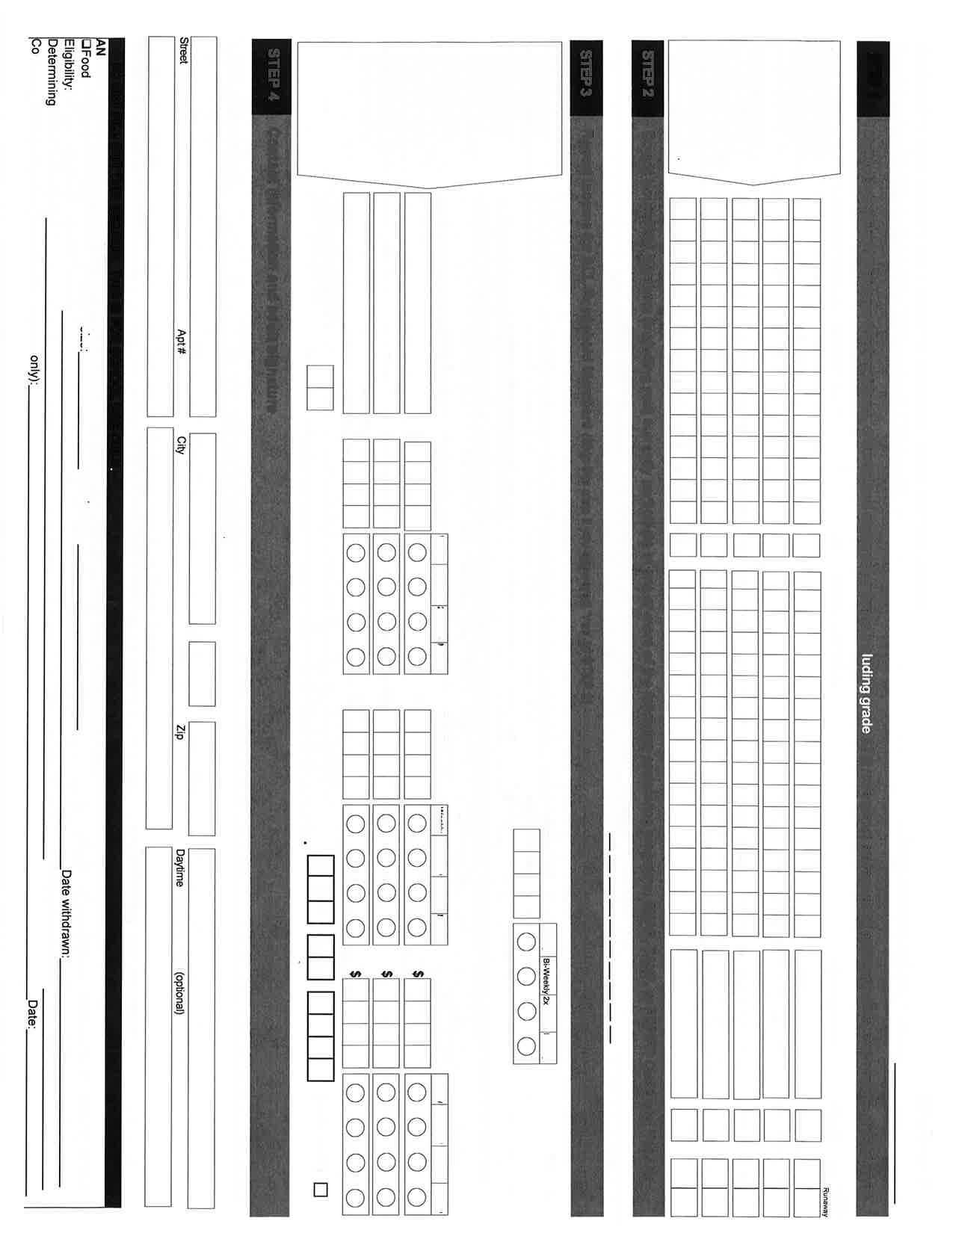
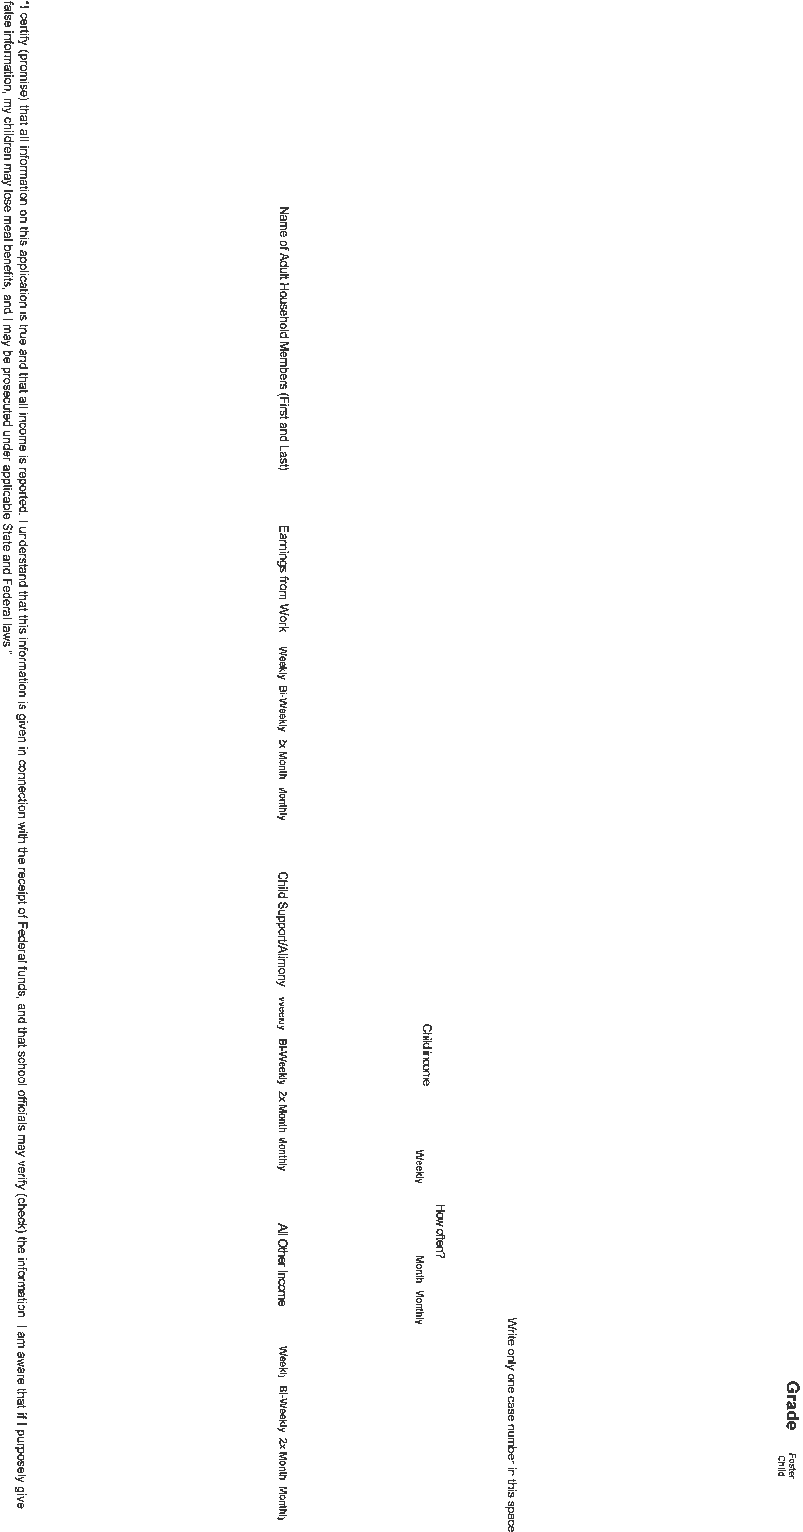
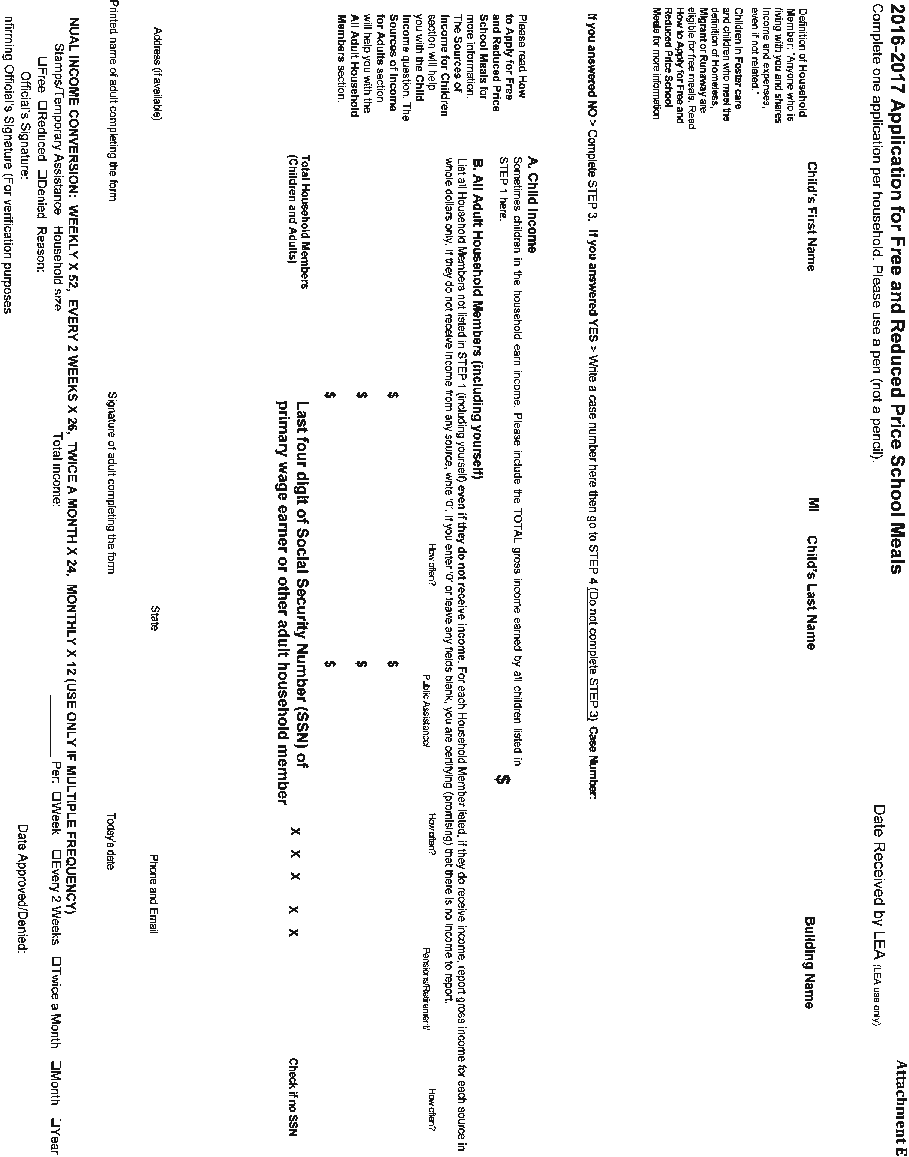
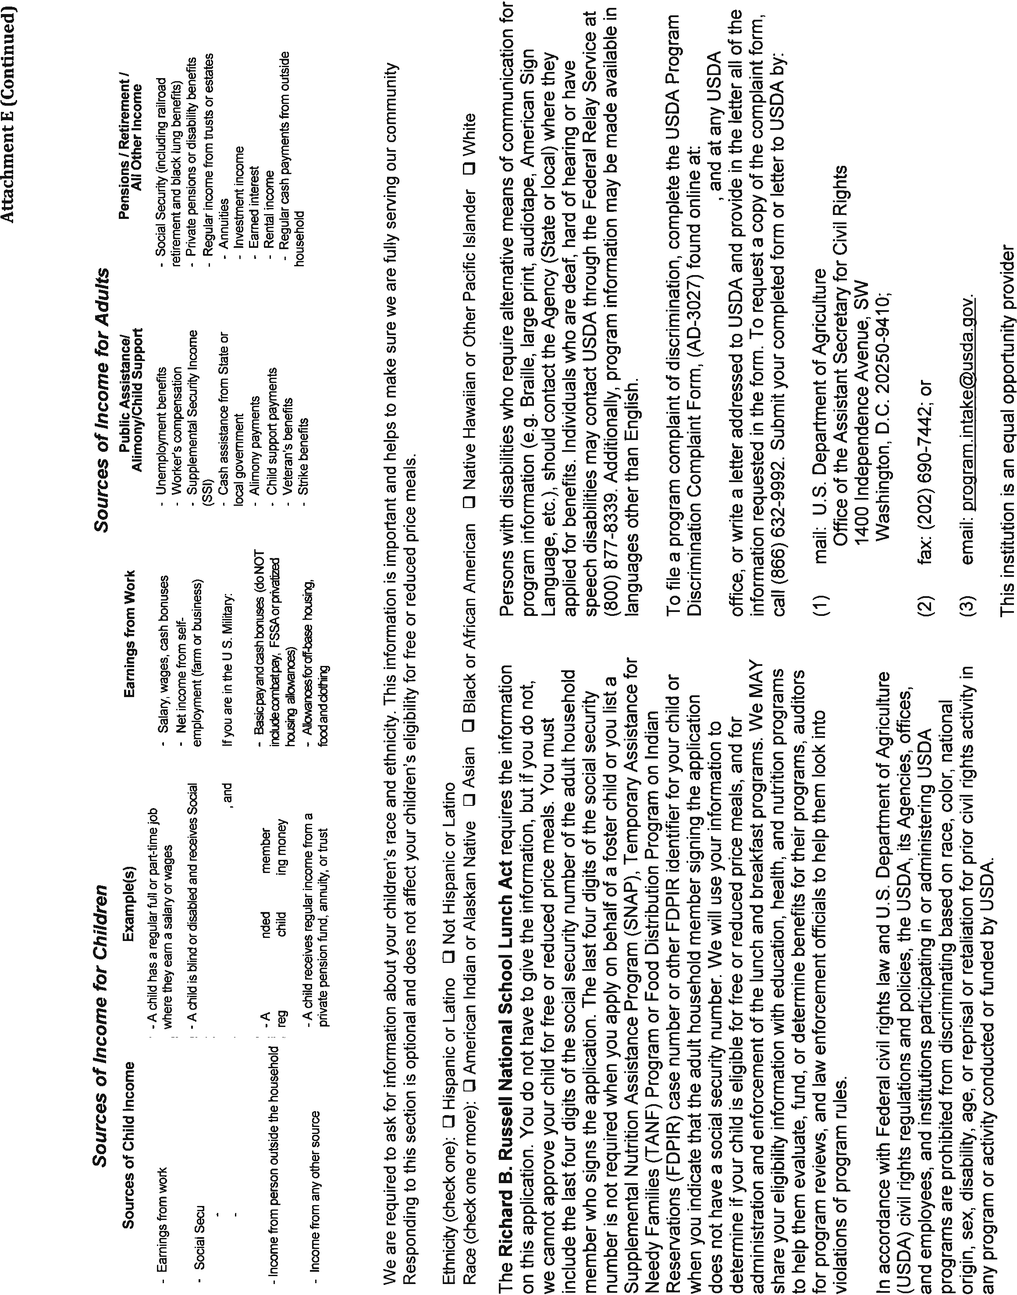

Public Release
July 21, 2016

South Nodaway School District announced its revised free and reduced price policy for school children unable to pay the full price of meals served in schools under the National School Lunch Program and the School Breakfast Program.
Local education officials have adopted the following family-size income criteria for determining eligibility:
Household | Maximum Household Income |  |  | Maximum Household Income
Size | Eligible for Free Meals |  |  | Eligible for Reduced Price Meals
 | Annually | Monthly | Weekly | Annually | Monthly | Weekly
1 | $15,444 | $1,287 | $297 | $21,978 | $1,832 | $423
2 | 20,826 | 1,736 | 401 | 29,637 | 2,470 | 570
3 | 26,208 | 2,184 | 504 | 37,296 | 3,108 | 718
4 | 31,590 | 2,633 | 608 | 44,955 | 3,747 | 865
5 | 36,972 | 3,081 | 711 | 52,614 | 4,385 | 1,012
6 | 42,354 | 3,530 | 815 | 60,273 | 5,023 | 1,160
7 | 47,749 | 3,980 | 919 | 67,951 | 5,663 | 1,307
8 | 53,157 | 4,430 | 1,023 | 75,647 | 6,304 | 1,455
Each add’l
member | + 5,408 | + 451 | + 104 | + 7,696 | +642 | + 148

Children from families whose current income is at or below those shown are eligible for free or reduced price meals. Applications are available at the school office. To apply, fill out a Free and Reduced Price School Meals Family Application and return it to the school. The information provided on the application is confidential and will be used only for the purpose of determining eligibility. Applications may be submitted any time during the school year. A complete application is required as a condition of eligibility. A complete application includes: (1) household income from all sources or Food Stamp/TANF case number, (2) names of all household members, and (3) the signature and last four digits of social security number or indication of no social security number of adult household member signing the application. School officials may verify current income at any time during the school year.

Foster children may be eligible regardless of the income of the household with whom they reside.
If a family member becomes unemployed or if family size changes, the family should contact the school to file a new application. Such changes may make the children of the family eligible for these benefits.
Households will be notified of their children’s eligibility status for free or reduced price meals. If any children were not listed on the eligibility notice for families receiving SNAP, TANF or FDPIR, the household should contact the school to have free meal benefits extended to those children.
If any child(ren) was not listed on the eligibility notice, the household should contact the LEA or school to have free meal benefits extended to that child(ren).
Under the provisions of the policy, the Superintendent will review the applications and determine eligibility. If a parent is dissatisfied with the ruling of the determining official, they may wish to discuss the decision with the hearing official on an informal basis or he/she may make a request either orally or in writing to the Board of Education.
Hearing procedures are outlined in the policy. A complete copy of the policy is on file in each school and in the central office where any interested party may review it.

USDA Non-discrimination Statement:
In accordance with Federal civil rights law and U.S. Department of Agriculture (USDA) civil rights regulations and policies, the USDA, its Agencies, offices, and employees, and institutions participating in or administering USDA programs are prohibited from discriminating based on race, color, national origin, sex, disability, age, or reprisal or retaliation for prior civil rights activity in any program or activity conducted or funded by USDA.
Persons with disabilities who require alternative means of communication for program information (e.g. Braille, large print, audiotape, American Sign Language, etc.), should contact the Agency (State or local) where they applied for benefits. Individuals who are deaf, hard of hearing or have speech disabilities may contact USDA through the Federal Relay Service at (800) 877-8339. Additionally, program information may be made available in languages other than English.
To file a program complaint of discrimination, complete the USDA Program Discrimination Complaint Form, (AD-3027) found online at: http://www.ascr.usda.gov/complaint_filing_cust.html, and at any USDA office, or write a letter addressed to USDA and provide in the letter all of the information requested in the form. To request a copy of the complaint form, call (866) 632-9992. Submit your completed form or letter to USDA by:
(1) mail: U.S. Department of Agriculture
Office of the Assistant Secretary for Civil Rights
1400 Independence Avenue, SW
Washington, D.C. 20250-9410;
(2) fax: (202) 690-7442; or
(3) email: program.intake@usda.gov.
This institution is an equal opportunity provider.

Request for Information
(Complete one form per family)

Please answer the question below by checking the appropriate box. The following information is a request adopted by the General Assembly in 2010 requiring school districts to determine whether or not all children in a family have health insurance.

Does each child in your family have healthcare insurance?

YES

NO

MO HealthNet (Medicaid) is considered healthcare insurance.

If NO is checked the school district will provide the Does Your Child Need Healthcare Coverage form for the family.

Completion of this form is not a condition of determining meal eligibility. The Free and Reduced Price Meals Family Application will be reviewed regardless of your response to this Request for Information.

Submit this request with your Free and Reduced Price School Meals Family Application or return to your school/school district.

Printed name of parent/guardian:

Mailing Address:

City: _________________________________ State: ___________ Zip: _____________

