Girls Fall Softball
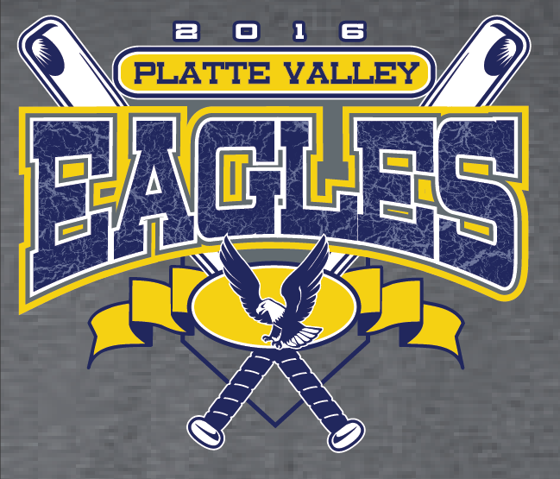
The shirts will be heather gray with a royal blue, gold and white logo design on the front.
The girls’ rosters will be on the back.
Each shirt is $10.
Youth Med 10-12, Youth Large 14-16, Adult S – XL.
Add $1.25 for 2XL, $2.50 for 3XL, $3.75 for 4XL & $5.00 for 5XL.
Make checks payable to Jefferson Schools.
Size | Adult/Youth | Total
 | Total

ORDERS DUE by noon on Sept. 2. SUBMIT FORMS & MONEY TO SHELLY DEEN.

Name ________________________________________________________________________________

