South Nodaway
Greenhouse Sale

Friday, April 28th 3:00 pm – 4:30 pm
Saturday, April 29th 9:00 am – Noon
Saturday, May 6th 9:00 am – Noon

Assorted Flower Varieties
Draceana Spikes
Sweet Potato & Vinca Vines
Impatiens
Petunias
Coleus
Calibrachoas
Alyssums

*Assorted hanging baskets and potted décor available for sale*
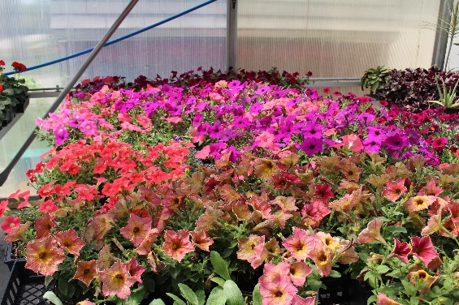
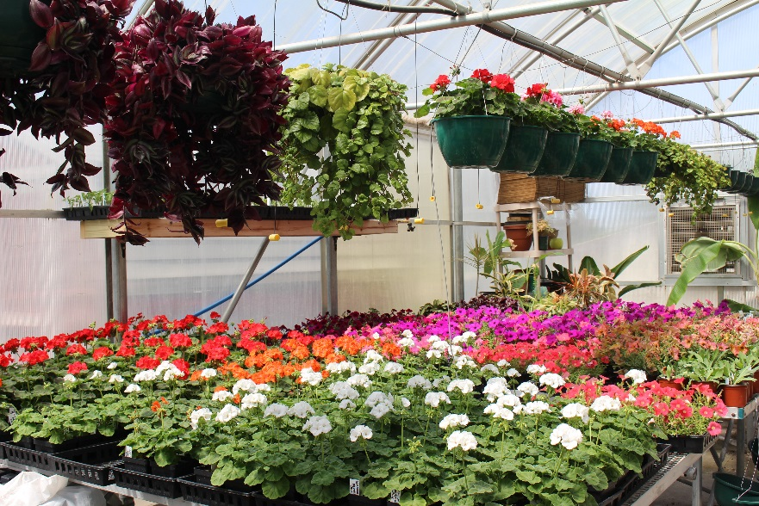
*Fountain Grasses*
*Assorted tomato varieties*

